**INFORMATION SECURITY**



**Session 2023 - 2027**

**Submitted by:**

Sumaira Hafeez 2023-CS-1

**Supervised by:**

Mam Faiza Iqbal

**Course:**

Information Security

Department of Computer Science

**University of Engineering and Technology**

**Lahore Pakistan**

Contents

**1.** **Windows Firewall:** 3

**2.** **Practical Implementation:** 3

• **Block Incoming Traffic:** 3

• **Block outgoing Traffic:** 4

• **Blocking port 80 for outgoing traffic:** 5

• **Block all UDP ports:** 6

• **Blocking Chrome on Computer:** 7

• **Block installation of Unlicensed Software** 8

**3.** **Security policy design and implementation** 9

• **Policy Options** 9

• **Password Policies** 9

• **Control Panel** 10

• **Restrict Access to Command Prompt** 10

• **Restrict Software Installations** 11

• **Disable Automatic Driver Update** 11

• **Disallow removable media drives** 12

• **Restrict Access of removable devices** 12

• **Fast Startup** 13

• **Application Start at Log On** 13

• **Applications Access** 14

• **AutoPlay** 14

Implementing Windows Firewall

# **Windows Firewall:**

**Windows Firewall** is a built-in security tool by Microsoft that filters network traffic to and from your system, blocking potentially harmful data or programs. A **firewall**, whether software or hardware-based, controls information entering your computer from the internet. If incoming data doesn't meet the filter rules, it is blocked.

# **Practical Implementation:**

## **Block Incoming Traffic:**

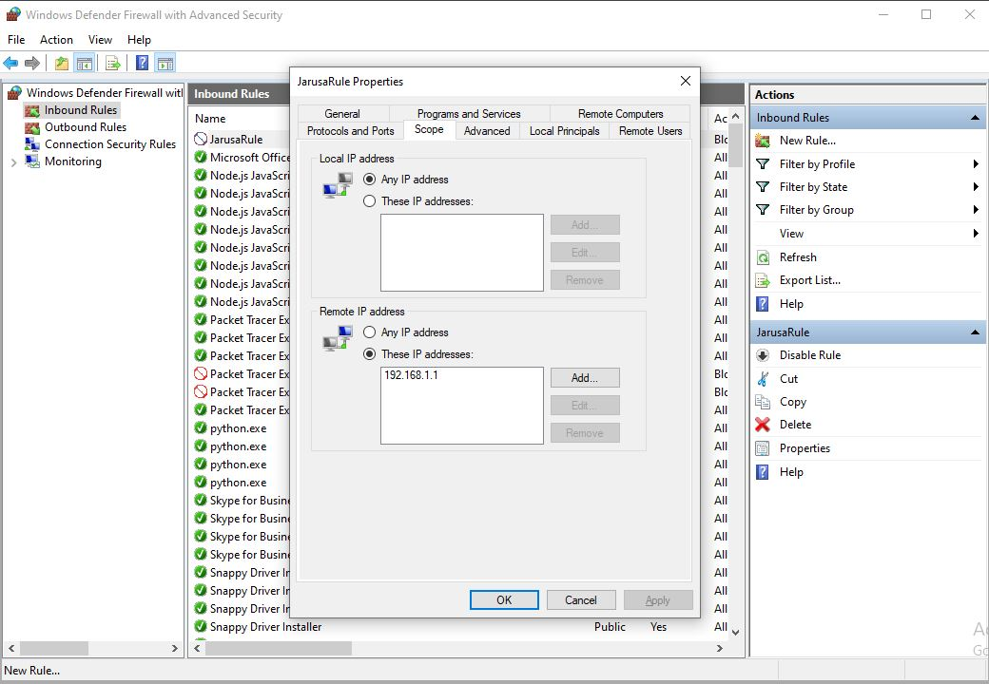

As a result, no effect is produced since it only blocks incoming traffic

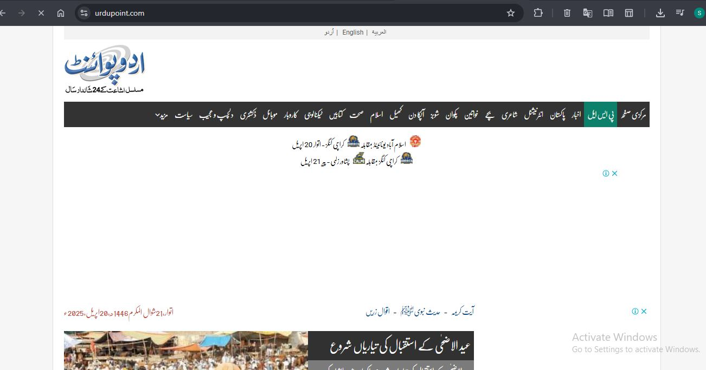

## **Block outgoing Traffic:**

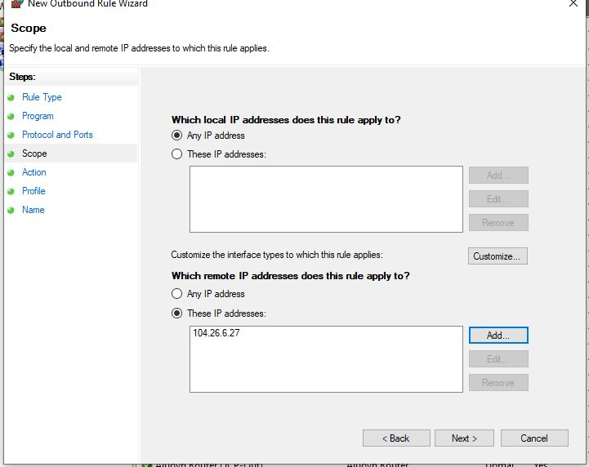

**As a result, Access denied at urdupoint.com**

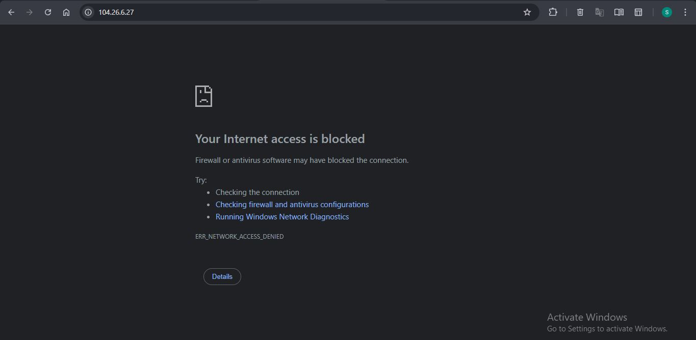

## **Blocking port 80 for outgoing traffic:**

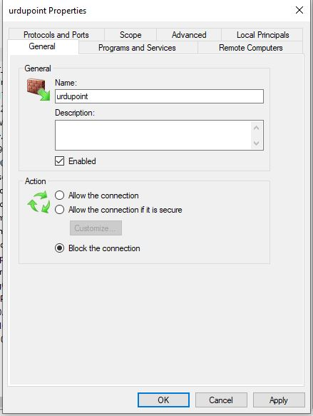

As a result, the access is blocked from browser now

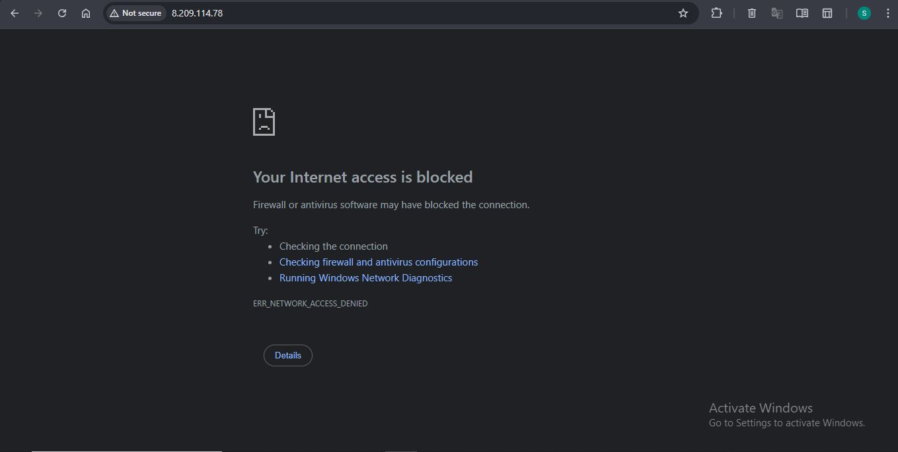

## **Block all UDP ports:**

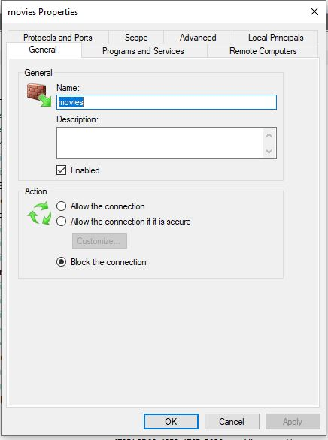

## **Blocking Chrome on Computer:**

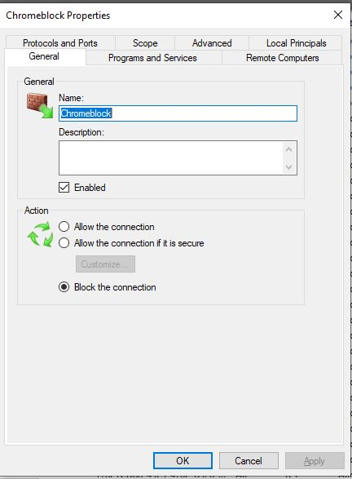

As a result, no software is working on chrome now

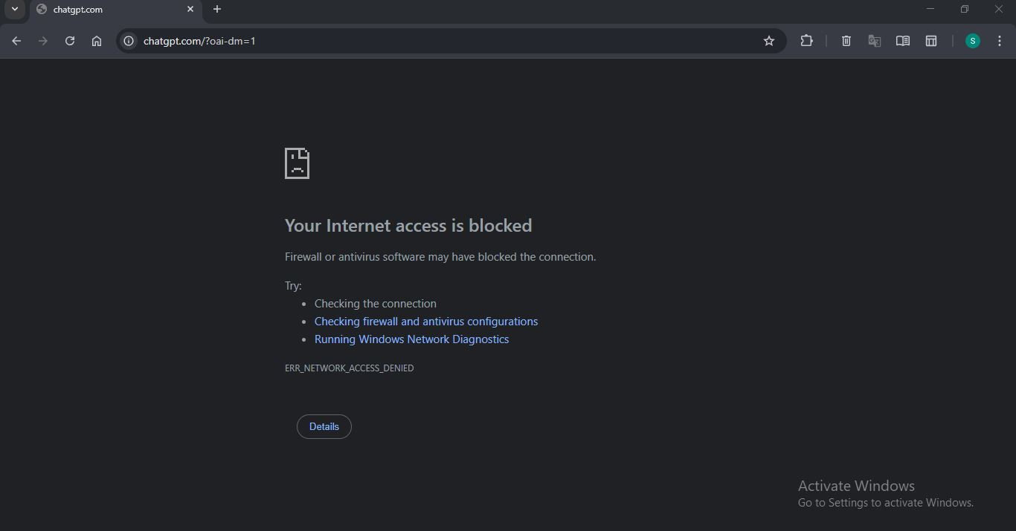

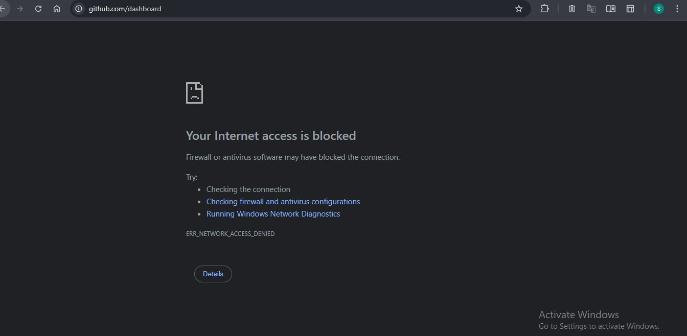

## **Block installation of Unlicensed Software**

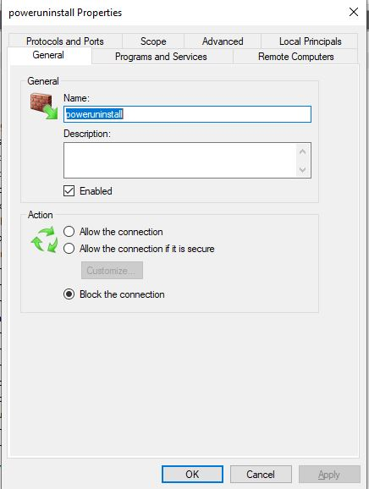

Now it is not able to execute.

# **Security policy design and implementation**

## **Policy Options**

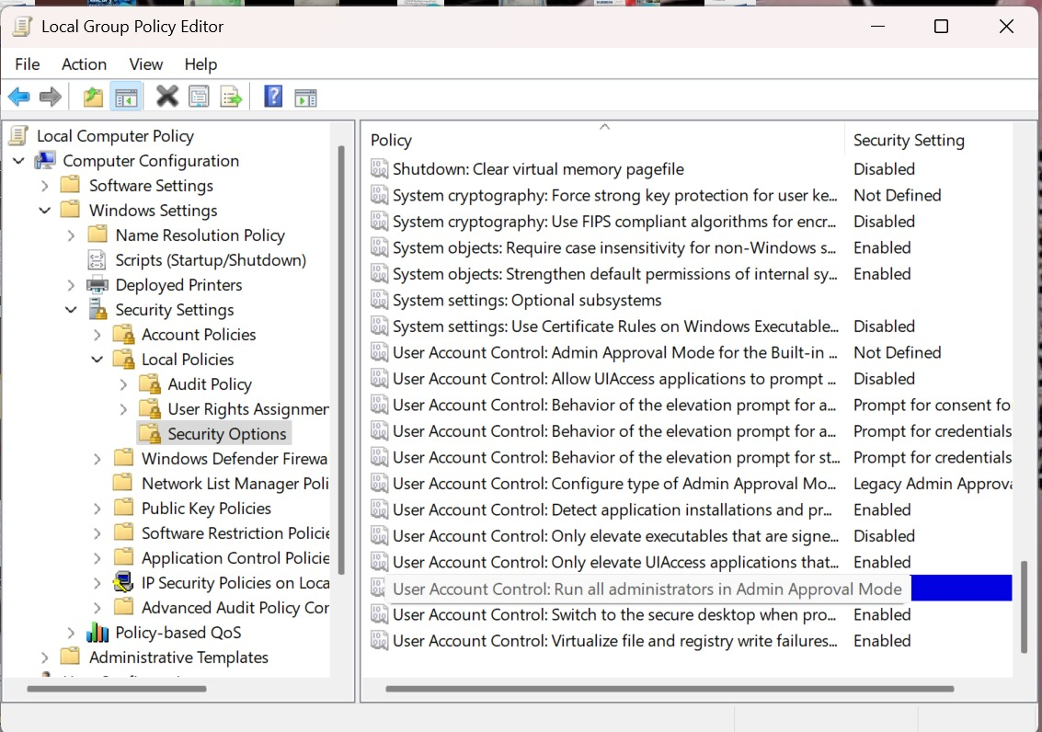

## **Password Policies**

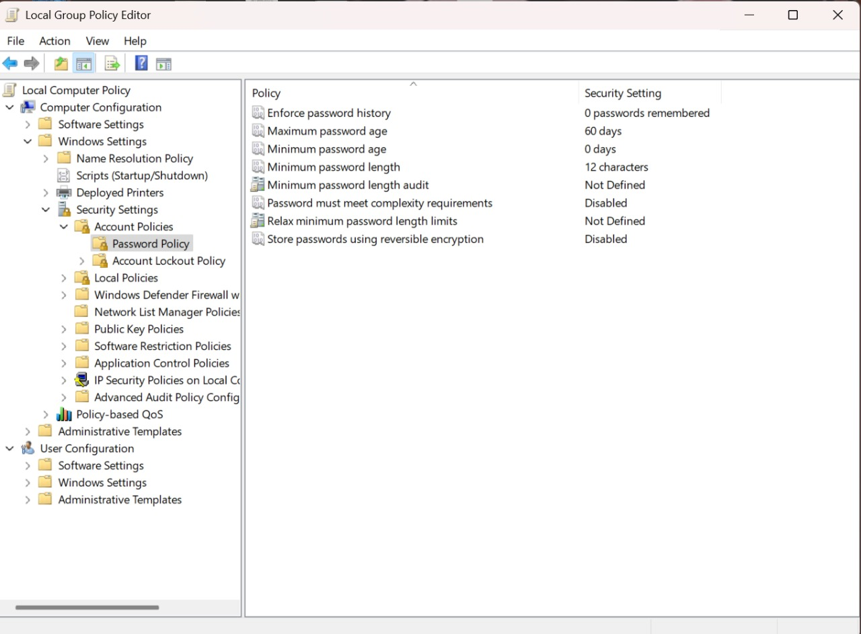

## **Control Panel**

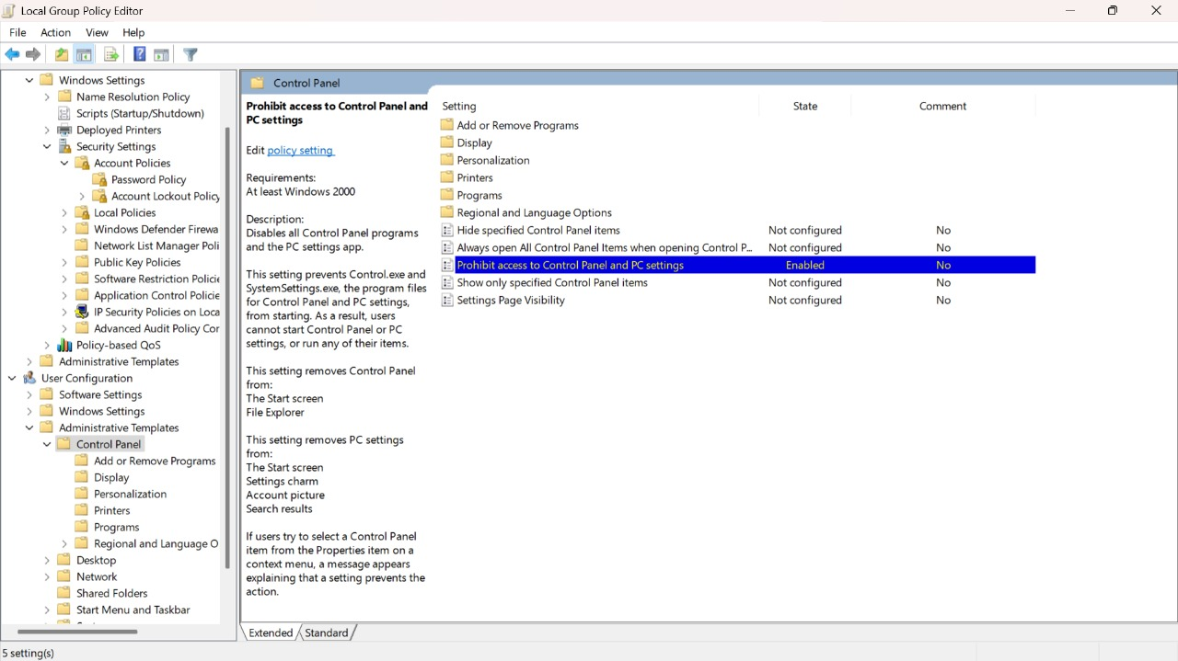

## **Restrict Access to Command Prompt**

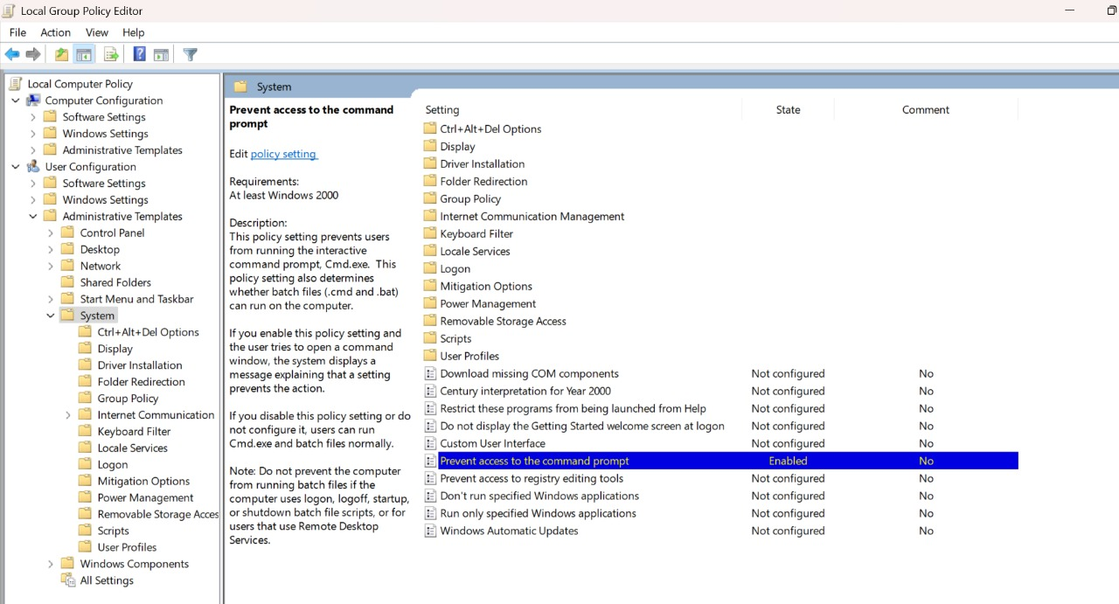

## **Restrict Software Installations**

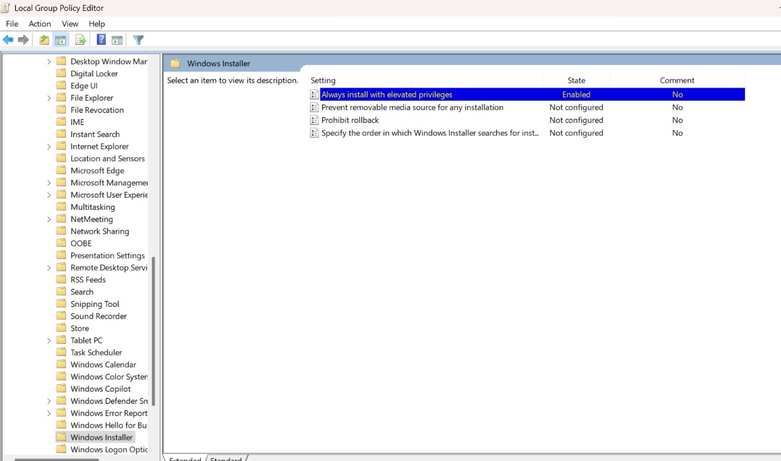

## **Disable Automatic Driver Update**

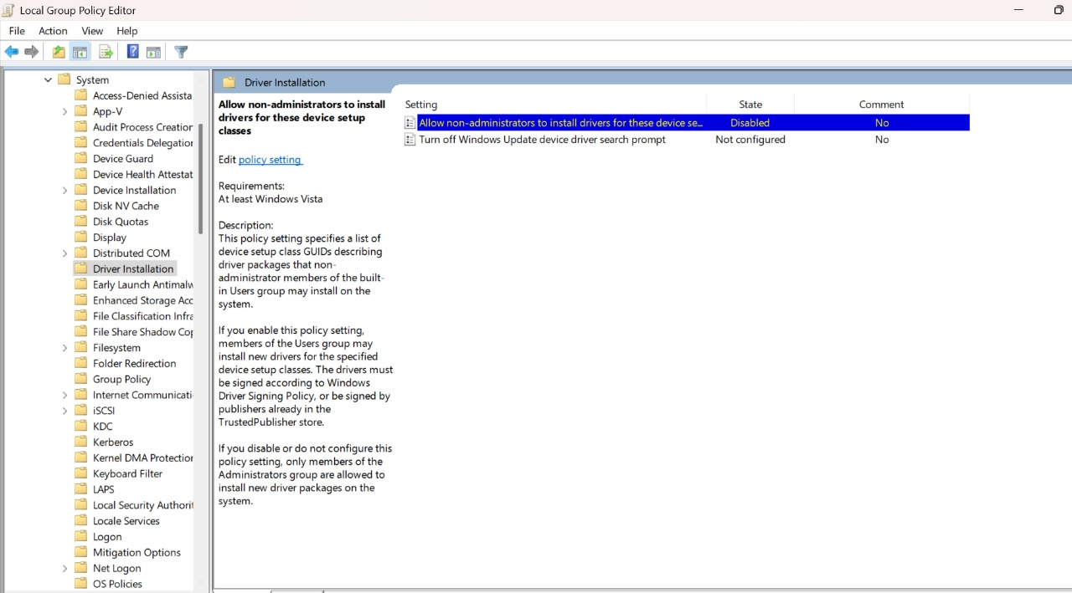

## **Disallow removable media drives**

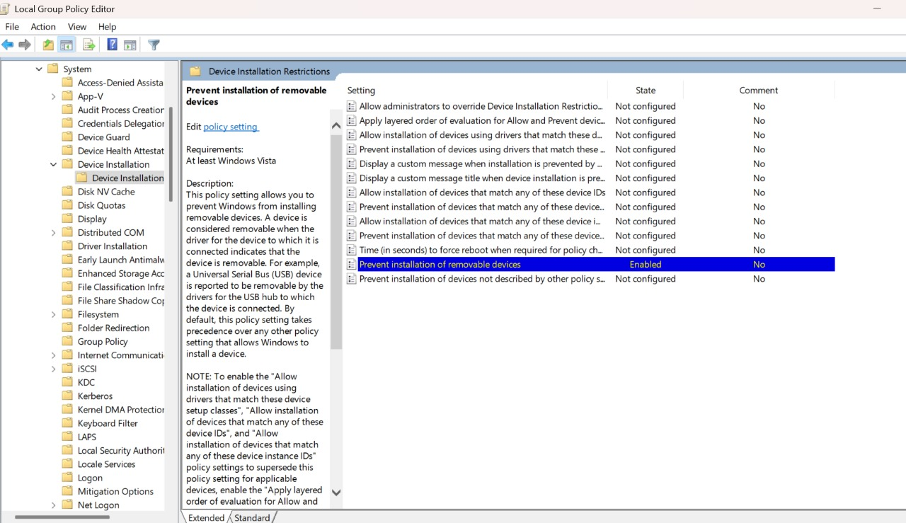

## **Restrict Access of removable devices**

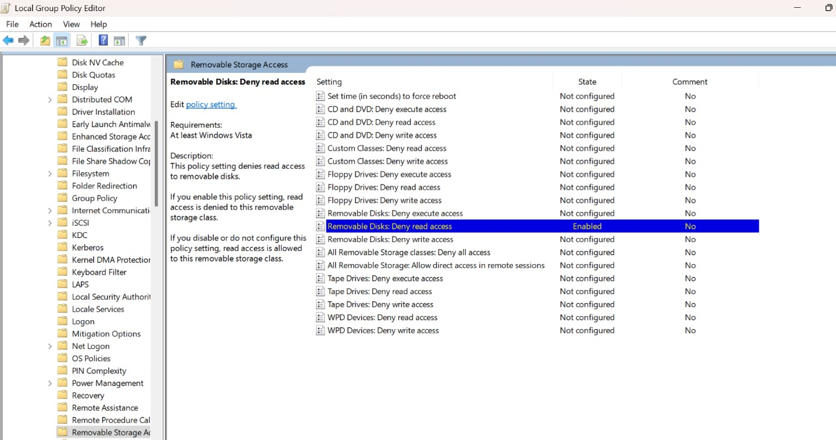

## **Fast Startup**

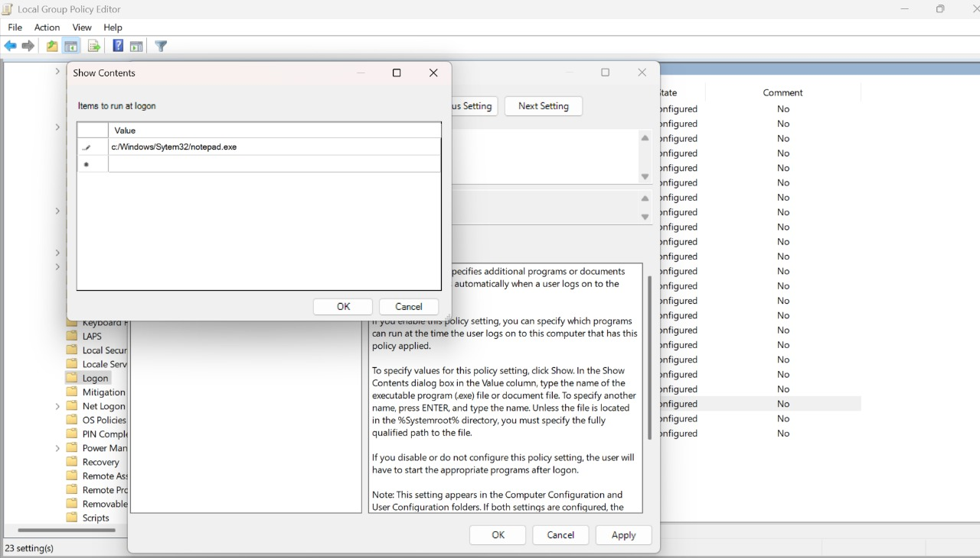

## **Application Start at Log On**

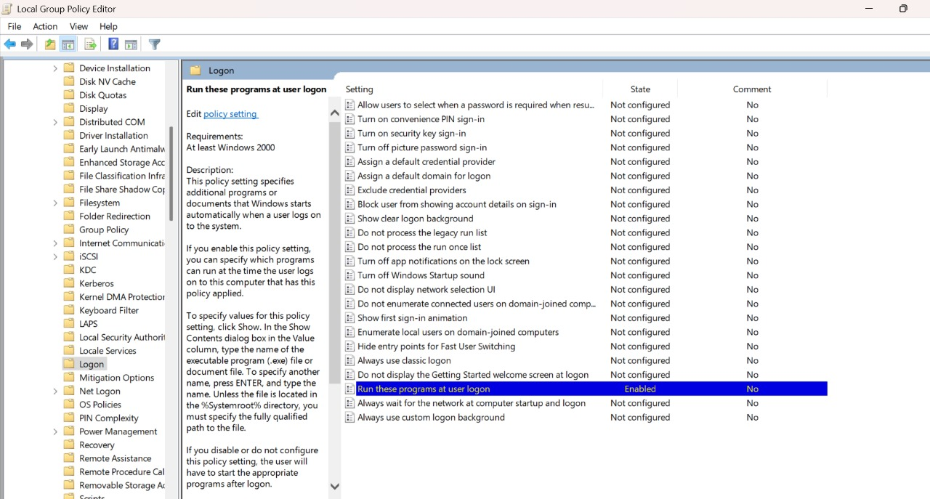

## **Applications Access**

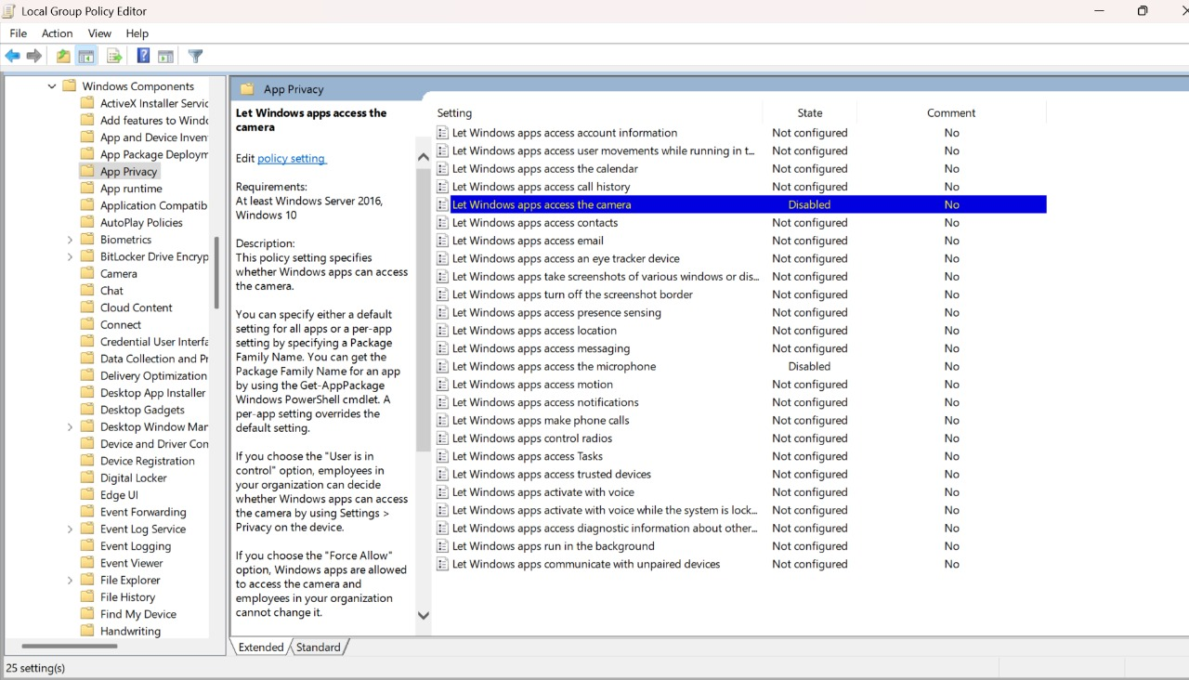

## **AutoPlay**

